**Pipeline:**

* In Jenkins pipeline, we can directly write the script in pipeline as below

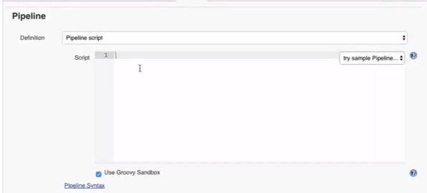

* Or we can get the script from SCM by giving the path name of script

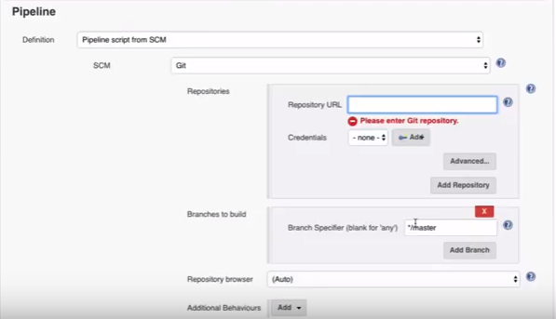

**Create scripts:**

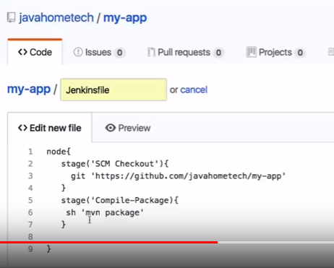

* After this, build might get failed, we can use pipeline syntax generator for our activities
* Inside job, at the last we can find the pipeline syntax generator option
* Using this, we can generate the pipeline syntaxes just by passing some inputs
* Select sample step and tool type, then generate the syntax

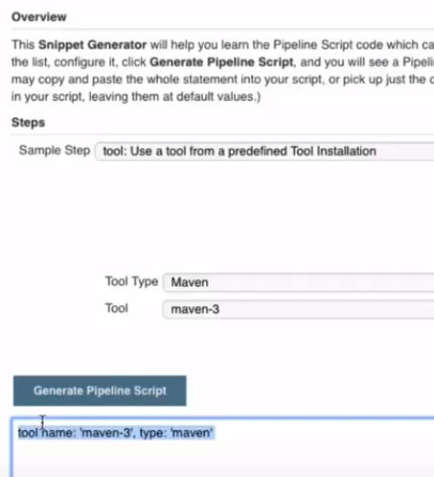

* This syntax helps to use the maven home directory. Use that as a variable in script

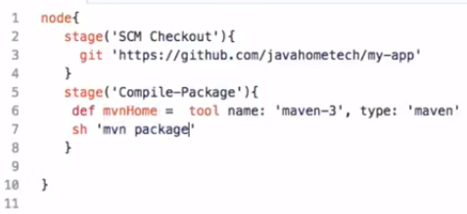

* We are giving complete path of maven home location with command

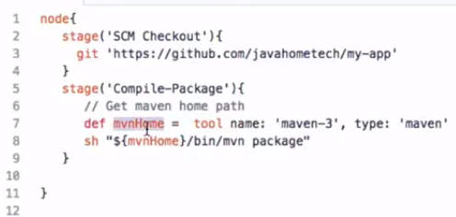

* We can use shell script as below and generate the script. For example, we don’t have maven step. So, we can use shell script as below

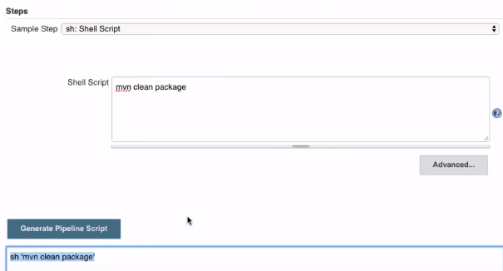

* Jenkins may can’t find the path to maven. So, we can use tool from predefined tool installation and generate the script

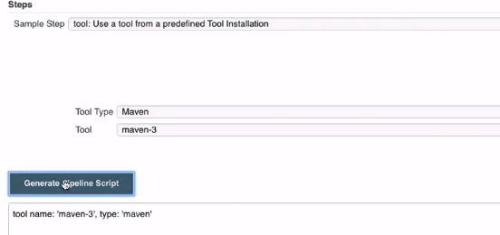

* The script returns the maven home path. So, Jenkins can run maven commands
* We can define the maven variable in script as below if we set maven as install automatically
* Even though after defining them, it won’t work. We need to set it in build step as below. It should be defined in “ “

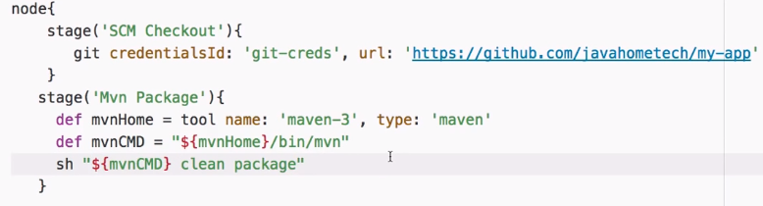

**Example:**

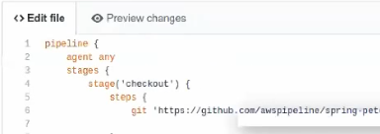

* We can give agent as any or the label name as below

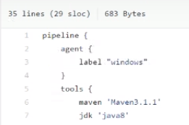

* Under tools, we can mention the tools that are going to be used by this job
* These are the names that we have given to the tools in global tool configuration settings

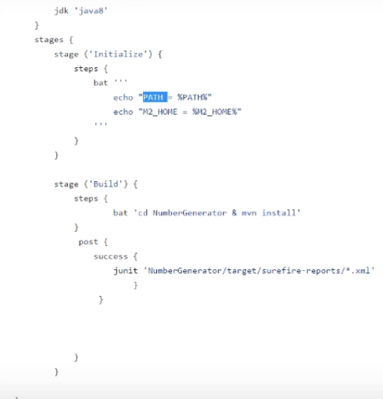

**Practice:**

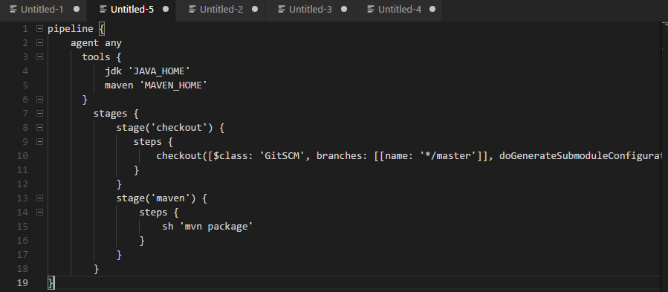

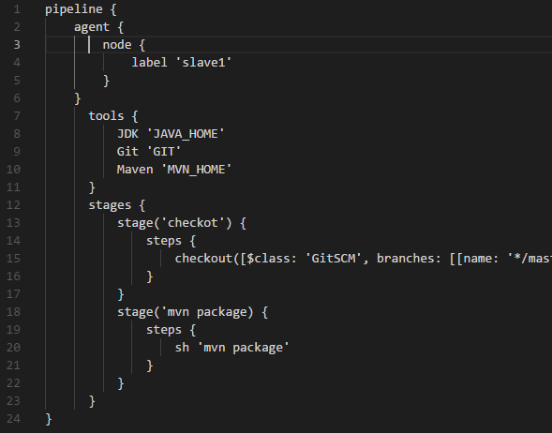

* Generated the nexus script as below

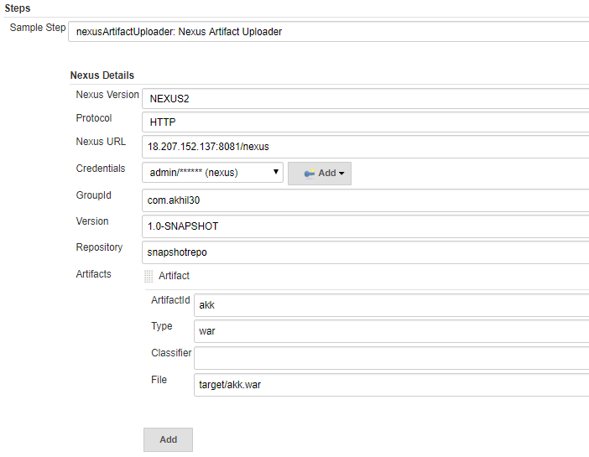

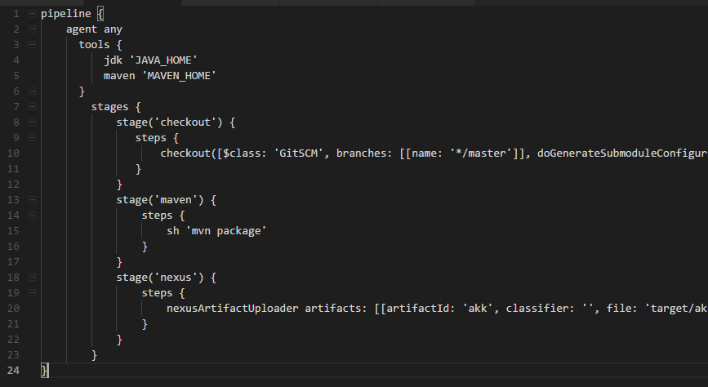

**Deployment with ansible:**

* Add ansible server under system settings for publish over ssh

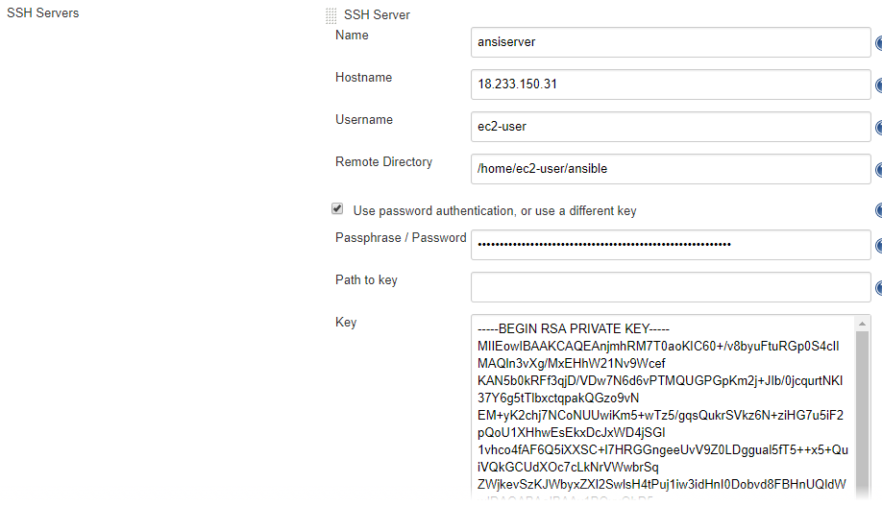

* Then create a pipeline script as below and run it

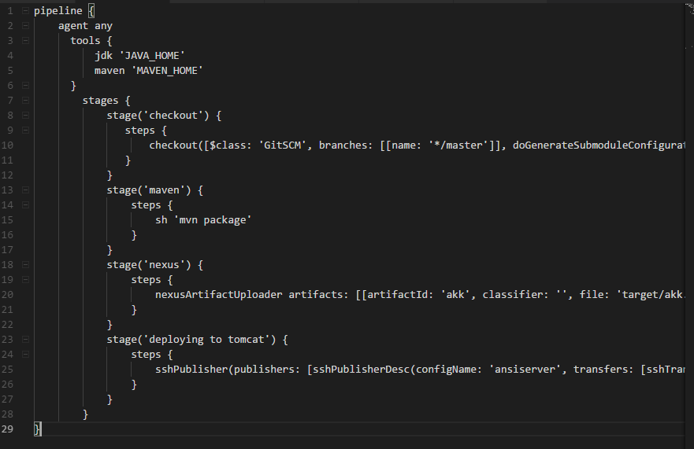

* Playbook as below

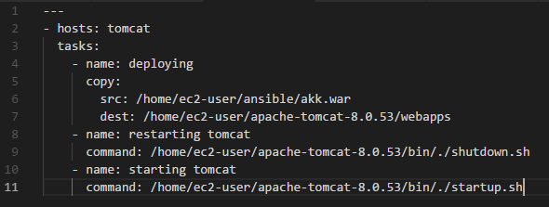

**Email notification:**

* Once we are done setting up the email in manage Jenkins, we need to generate a script as below and add that to the pipeline script

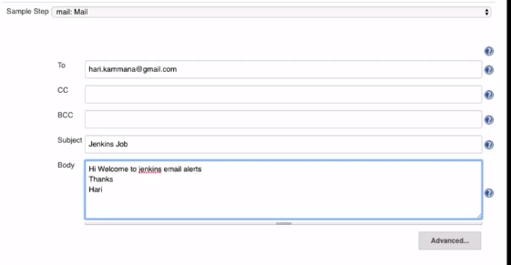

* Select properties: job properties as below for any setting or build triggers to generate a script

